Assignment 15.4
Amogh Mukherjee
Here is a picture of the prototype with the implemented GUI:
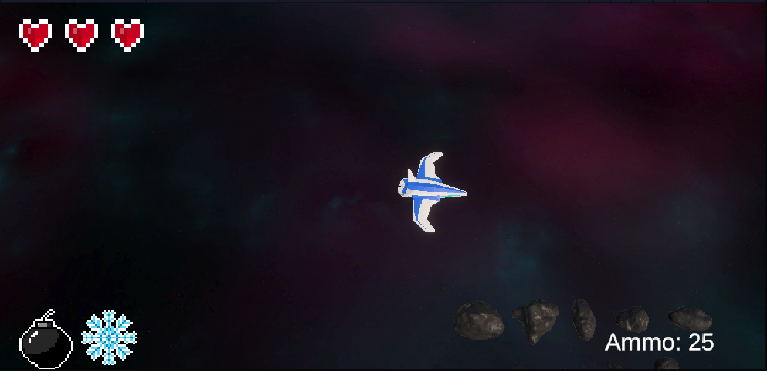
Let’s go through each GUI element.
The hearts in the top left corner are part of an asset pack I downloaded from the Unity asset store. While I made the other two sprites in this image by hand, I wasn’t sure how to handle health in the prototype, since to make this UI fully functional I would’ve had to implement quite a lot of other mechanics and I simply didn’t have the time to do it this week, though I’m planning to replace this element eventually with a more thematically appropriate one. The hearts do not update in this prototype since right now there are no sources of damage.
In the bottom left corner, we have the symbols for the two superpowers I plan to give the player character: a bomb that clears the screen, and a freeze ray that stops enemies and projectiles in their place. I made these sprites by hand, since I wanted to practice doing that. These, like the hearts in the top left corner, do not update, since I haven’t implemented the superpowers yet.
Lastly, in the bottom right corner, we have an ammo counter that counts down from 25 to zero. When it hits zero, the text is replaced with “Reload!”, and once you press either the spacebar or the left trigger on the gamepad, the counter jumps back up to 25 again. Since I already had a shooting mechanic implemented, it wasn’t too hard to implement a simple ammo/reloading mechanic that updated the GUI.
In the final game, I plan to add some animations to the health/superpower sprites, and to make the reload counter more thematic/complicated. I briefly considered making a minimap, but like a lot of other features, it would require me to implement too many other features to be worth considering at this point in the project. This is a minimal GUI. I didn’t want to implement too many features before deciding on what works and what doesn’t.

